WEEK – 5

Creating Microservices for account and loan

Nipuna

Superset id: 6432842

**Loan Microservice**

* Follow similar steps specified for Account Microservice and implement a service API to get loan account details
  + Method: GET
  + Endpoint: /loans/{number}
  + Sample Response. Just a dummy response without any backend connectivity.

{ number: "H00987987972342", type: "car", loan: 400000, emi: 3258, tenure:

18 }

* Launching this application by having account service already running
* This launch will fail with error that the bind address is already in use
* The reason is that each one of the service is launched with default port number as 8080. Account service is already using this port and it is not available for loan service.
* Include "server.port" property with value 8081 and try launching the application
* Test the service with 8081 port

Now we have two microservices running on different ports.

**NOTE:** The console window of Eclipse will have both the service console running. To switch between different consoles use the monitor icon within the console view.

Solution:

1)LoaApplication.java:

**package** com.cognizant.loan;

**import** org.springframework.boot.SpringApplication;

**import** org.springframework.boot.autoconfigure.SpringBootApplication;

@SpringBootApplication

**public** **class** LoanApplication {

**public** **static** **void** main(String[] args) {

SpringApplication.*run*(LoanApplication.**class**, args);

}

}

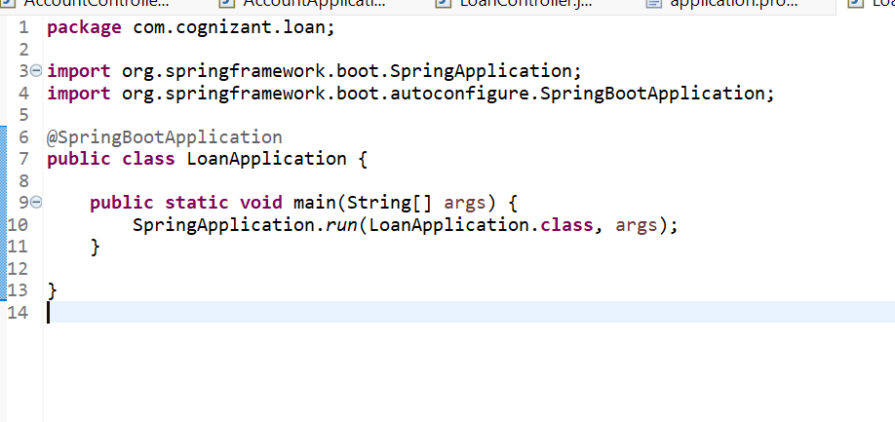

2)LoanController.java:

**package** com.cognizant.loan.controller;

**import** org.springframework.web.bind.annotation.GetMapping;

**import** org.springframework.web.bind.annotation.PathVariable;

**import** org.springframework.web.bind.annotation.RestController;

**import** java.util.Map;

@RestController

**public** **class** LoanController {

@GetMapping("/loans/{number}")

**public** Map<String, String> getLoanDetails(@PathVariable String number) {

**return** Map.*of*(

"loanNumber", number,

"loanHolder", "Jane Smith",

"loanType", "Home Loan",

"status", "Approved"

);

}

}

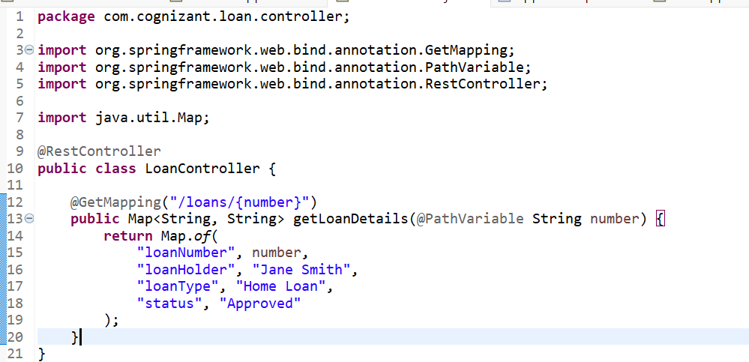

3)ApplicationProperties:

spring.application.name=loan

server.port=8081

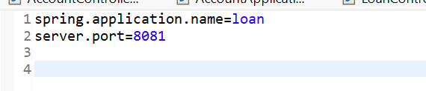

Output:

